
General chemistry
lab component CHE101L
Content: Lab 3

Dissolution Reactions: Heats of Dissociation

Name :Asifur Rahman Apon SECTION: 20
Student ID : 2512131642
Date & time …………………………………

Name of the instructor …………………………………………………….
Signature & date ………………………………………….
report submission date ……………………………

Experiment 3
Dissolution Reactions: Heats of Dissociation
Heats (exothermic or endothermic) are associated with chemical reactions. Quantity of heat evolved or absorbed is directly proportional to the amount reacted. Consider the reaction:
MgSO4(s) + H₂O (l) Mg ²⁺(aq.) + SO₄ ²⁻(aq.) ± heat
Heat could be generated or absorbed in this reaction. When heat is generated/released from a chemical reaction it is called exothermic reaction (you can feel it by touching the reaction container (warmer) and when heat is absorbed the reaction is called endothermic (colder). When reactions occur in a reaction vessel (e.g., Beaker) in aqueous condition, formation and dissociation of chemical bonds occur simultaneously. Bond formation and dissociation involves heat energy of the system which is expressed by the term Q which is called enthalpy.
Problem statement: Is heat energy related to chemical reactions, how?
This experiment is subdivided into two parts:
- Qualitative & II. Quantitative

Part I. Qualitative
Data Collection:
Place about 30 mL of distilled water into a 50 mL beaker. Suspend a thermometer (having 0.1⁰C division mark) into the beaker using thermometer clamp and ring stand. Please make sure that the thermometer is not touching the bottom of the beaker, as any movement of the beaker could break the thermometer. Record the temperature of water in the beaker in every 30 seconds for 240 seconds.
Figure 1: Experimental setup for dissolution reaction

Place a moderate amount (which would be 1 to 3 cm³) of supplied anhydrous magnesium sulfate (MgSO₄) to the beaker. Mix vigorously with the glass rod for 5 minutes. Record your observations. (2 points)

Mixing anhydrous magnesium sulfate (MgSO4) with water yields a clear solution. MgSO4 dissolves readily in H20. After mixing, the clarity of the solution increases.
MgSO₄ → 23°C - 35°C→ Exothermic

Repeat this procedure with each of the following compounds: (2 points)

- Sodium Nitrate, NaNO₃ : 26.25°C - 23°C→ Endothermic
- Sodium Chloride, NaCl : 26°C - 25°C→ Endothermic
- Hydrated Calcium Chloride, CaCl₂.2H₂O: 25°C - 27°C→ Exothermic
- Ammonium Nitrate, NH₄NO₃ : 26.25°C - 21°C→ Endothermic
- anhydrous magnesium sulfate (MgSO4) : 26°C - 28.25°C→ Exothermic

Data Analysis:
What are the similarities and differences in the behavior of these compounds? Can you find out any generalization concerning all chemical reactions here? What conclusion can be drawn from these data?
(4 points)

The compounds given are NaNO₃, NaCl, CaCl₂·2H₂O, NH₄NO₃ and MgSO₄. Among all of them, NaNO₃, NaCl, and NH₄NO₃ are endothermic compounds. They absorb heat from their surrounding. In the chemical reaction, the initial temperature of the water decreases after these compounds are added.
On the other hand, CaCl₂·2H₂O and MgSO₄ are exothermic compounds. During the chemical reaction, the initial temperature of the water increases, and these compounds release heat.

Part II. Quantitative
Data Collection:
- Accurately weigh a 3 to 5 gm sample of MgSO₄ on the analytical balance. Record the exact mass here. For 4 different trials below measure four different weight samples (e.g., 1,2, 4 & 5 grams respectively).
- Suspend the thermometer into a polystyrene cup/coffee cup. Make sure of the thermometer is not touching the bottom of the cup. Measure 20 mL of distilled water by a volumetric cylinder into the cup and stir for 240 second. Record the temperature in every 20 seconds. After 240 seconds add MgSO₄ with vigorous mixing while continuing to record data for 5 minutes.
- Determine the temperature change, ΔT, for the reaction. This can be done from the difference of the highest temperature minus the slope of the line go through the points from first 240 seconds of data.
- Draw a temperature vs. time graph. Draw the best curve through the points and point out what is happing in each part of the curve.

Data Table:
Trails

(I) Mass of MgSO₄ __0.5 gm__ |  |  | (II) Mass of MgSO₄__1.0 gm__
Time (s) | Temp(⁰C) |  | Time(s) | Temp(⁰C)
20 | 24.75 |  | 20 | 24
40 | 24.75 |  | 40 | 24.5
60 | 24.75 |  | 60 | 24.75
80 | 25.25 |  | 80 | 25.25
100 | 25.75 |  | 100 | 25.25
120 | 26 |  | 120 | 25.25
140 | 26 |  | 140 | 25.75
160 | 26 |  | 160 | 25.75
180 | 26 |  | 180 | 25.75
200 | 25.75 |  | 200 | 26
220 | 25.5 |  | 220 | 26
240 | 25.5 |  | 240 | 26
260 | 25.25 |  | 260 | 26
280 | 25.25 |  | 280 | 26
300 | 25.25 |  | 300 | 26

(III) Mass of MgSO₄ __1.5 gm__ |  |  | (IV) Mass of MgSO₄__2.0 gm__
Time (s) | Temp(⁰C) |  | Time(s) | Temp(⁰C)
20 | 24.75 |  | 20 | 24
40 | 24.75 |  | 40 | 24
60 | 24.75 |  | 60 | 24
80 | 27 |  | 80 | 24.9
100 | 27.25 |  | 100 | 25
120 | 27.75 |  | 120 | 25
140 | 28 |  | 140 | 25.20
160 | 26.75 |  | 160 | 25.30
180 | 26.25 |  | 180 | 25.70
200 | 26.20 |  | 200 | 25.70
220 | 26.10 |  | 220 | 25.87
240 | 26 |  | 240 | 25.87
260 | 26 |  | 260 | 25.90
280 | 25.75 |  | 280 | 25.90
300 | 25.5 |  | 300 | 25.90

(I) Mass of NaNO₃ __0.5 gm__ |  |  | (II) Mass of NaNO₃__1.0 gm__
Time (s) | Temp(⁰C) |  | Time(s) | Temp(⁰C)
20 | 24.75 |  | 20 | 24.5
40 | 24.75 |  | 40 | 25
60 | 24.75 |  | 60 | 25
80 | 22.75 |  | 80 | 24.25
100 | 22 |  | 100 | 24
120 | 22 |  | 120 | 24
140 | 21.90 |  | 140 | 24
160 | 21.80 |  | 160 | 23.25
180 | 21.75 |  | 180 | 23
200 | 21.70 |  | 200 | 23
220 | 21 |  | 220 | 23
240 | 20.90 |  | 240 | 23
260 | 20.80 |  | 260 | 23
280 | 20.72 |  | 280 | 22.75
300 | 20 |  | 300 | 22.75

(III) Mass of NaNO₃ __1.5 gm__ |  |  | (IV) Mass of NaNO₃__2.0 gm__
Time (s) | Temp(⁰C) |  | Time(s) | Temp(⁰C)
20 | 24.70 |  | 20 | 24.25
40 | 24.70 |  | 40 | 24.25
60 | 24.70 |  | 60 | 24.25
80 | 21.50 |  | 80 | 23
100 | 21.20 |  | 100 | 22.25
120 | 21 |  | 120 | 22
140 | 20.50 |  | 140 | 21.75
160 | 20.30 |  | 160 | 21.75
180 | 20.30 |  | 180 | 21.50
200 | 20.30 |  | 200 | 21.25
220 | 20.20 |  | 220 | 21
240 | 20.20 |  | 240 | 21
260 | 20.20 |  | 260 | 21
280 | 20 |  | 280 | 21
300 | 20 |  | 300 | 21

Data Analysis
- What do you understand form the data you recorded and from the other trials?(4 points)

When MgSO₄ is added to water, the initial temperature of the water rises gradually, which indicates an exothermic reaction. The rise in temperature is measured by the amount of MgSO₄ added. The highest temperature increase is observed in the highest concentration of MgSO₄.
The temperature decreases with increasing concentration of NaNO₃, which indicates an endothermic reaction. From the trial and collected data, we can conclude that the heat relies on mass, an increase in concentration, and an increase in the reaction rate.

- Calculate the heat, Q & moles, n, of the reaction. Take help from the equitation Q = C x M x ΔT. Assume C = 4.18 Joules/gram ⁰C and M is the mass of water (take the water density as 1.00 grams/cm³). (4 points)
For MgSO₄ :
Q₁ = C X M X ∆T
= 4.18 X 20 X (26-24.75) J
= 104.5J
Q₂ = C X M X ∆T
= 4.18 X 20 X (26-24) J
= 167.2J
Q₃ = C X M X ∆T
= 4.18 X 20 X (28-24.75) J
= 271.7J
Q₄ = C X M X ∆T
= 4.18 X 20 X (25.90-24) J
= 158.84
n_{1= 0.5/120 = 0.0041}
n_{1= 1.0/120 = 0.0083}
n_{1= 1.5/120 = 0.0125}
n_{1= 2.0/120 = 0.0167}

For NaNO₃ :
Q₁ = C X M X ∆T
= 4.18 X 20 X (20--24.75) J
= -397.1 J
Q₂ = C X M X ∆T
= 4.18 X 20 X (22.75-25) J
= -188.1 J
Q₃ = C X M X ∆T
= 4.18 X 20 X (20—24.70) J
= -392.92J
Q₄ = C X M X ∆T
= 4.18 X 20 X (21-24.25) J
= -271.70
n_{1= 0.5/85= 0.00459}
n_{1= 1.0/85= 0.0118}
n_{1= 1.5/85 = 0.0177}
n_{1= 2.0/85 = 0.0235}

- Plot the collected data as moles, n vs. Q. Number of moles can be calculated as n = (mass of sample in gram) / (molecular weight in grams/mole). Try to find an algebraic equation. (4 points)

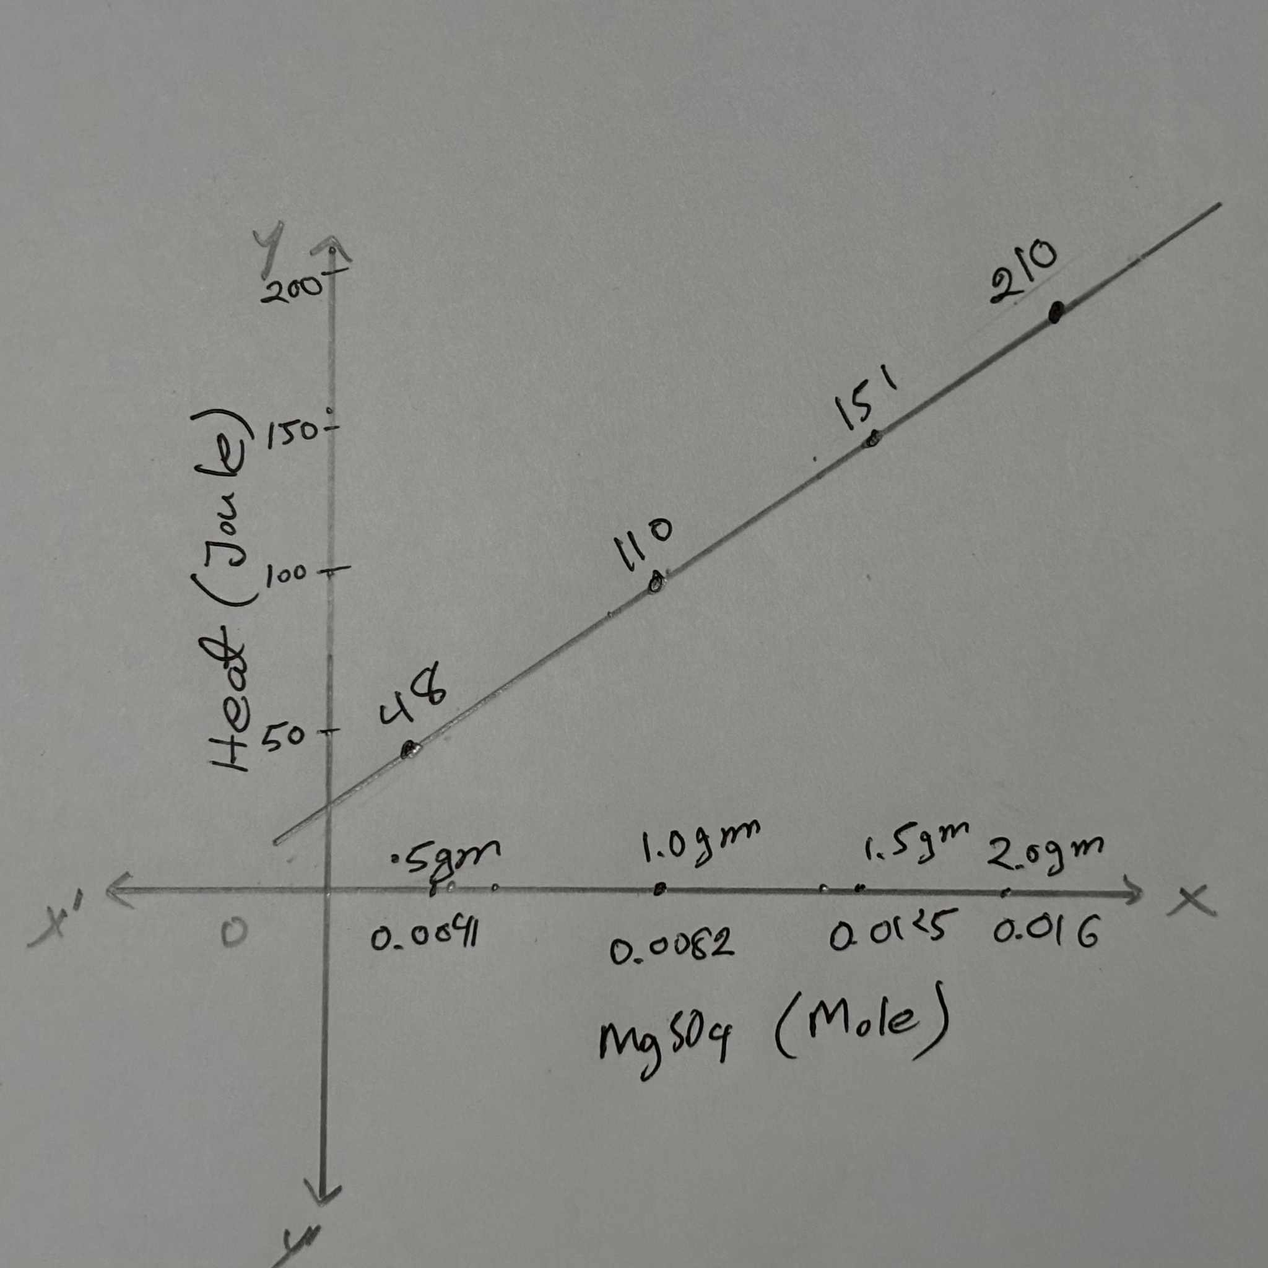

The graph i drew shows a straight-line relationship between two variables:
- x-axis: Moles of MgSO₄
- y-axis: Heat released (Joules)
Because the data points lie on a straight line and the line you drew is linear, the relationship follows the standard linear equation form:
y=mx+c
Where:
- y = Heat (Joules)
- x = Moles of MgSO₄
- m = Slope (heat released per mole)
Mental Model: Use the chemical equation given above to represent the dissolution reaction in this experiment. Draw a picture(s) which describes what is happening in atomic or in molecular level. How heat release or absorbed can be described from these pictures? (5 points)
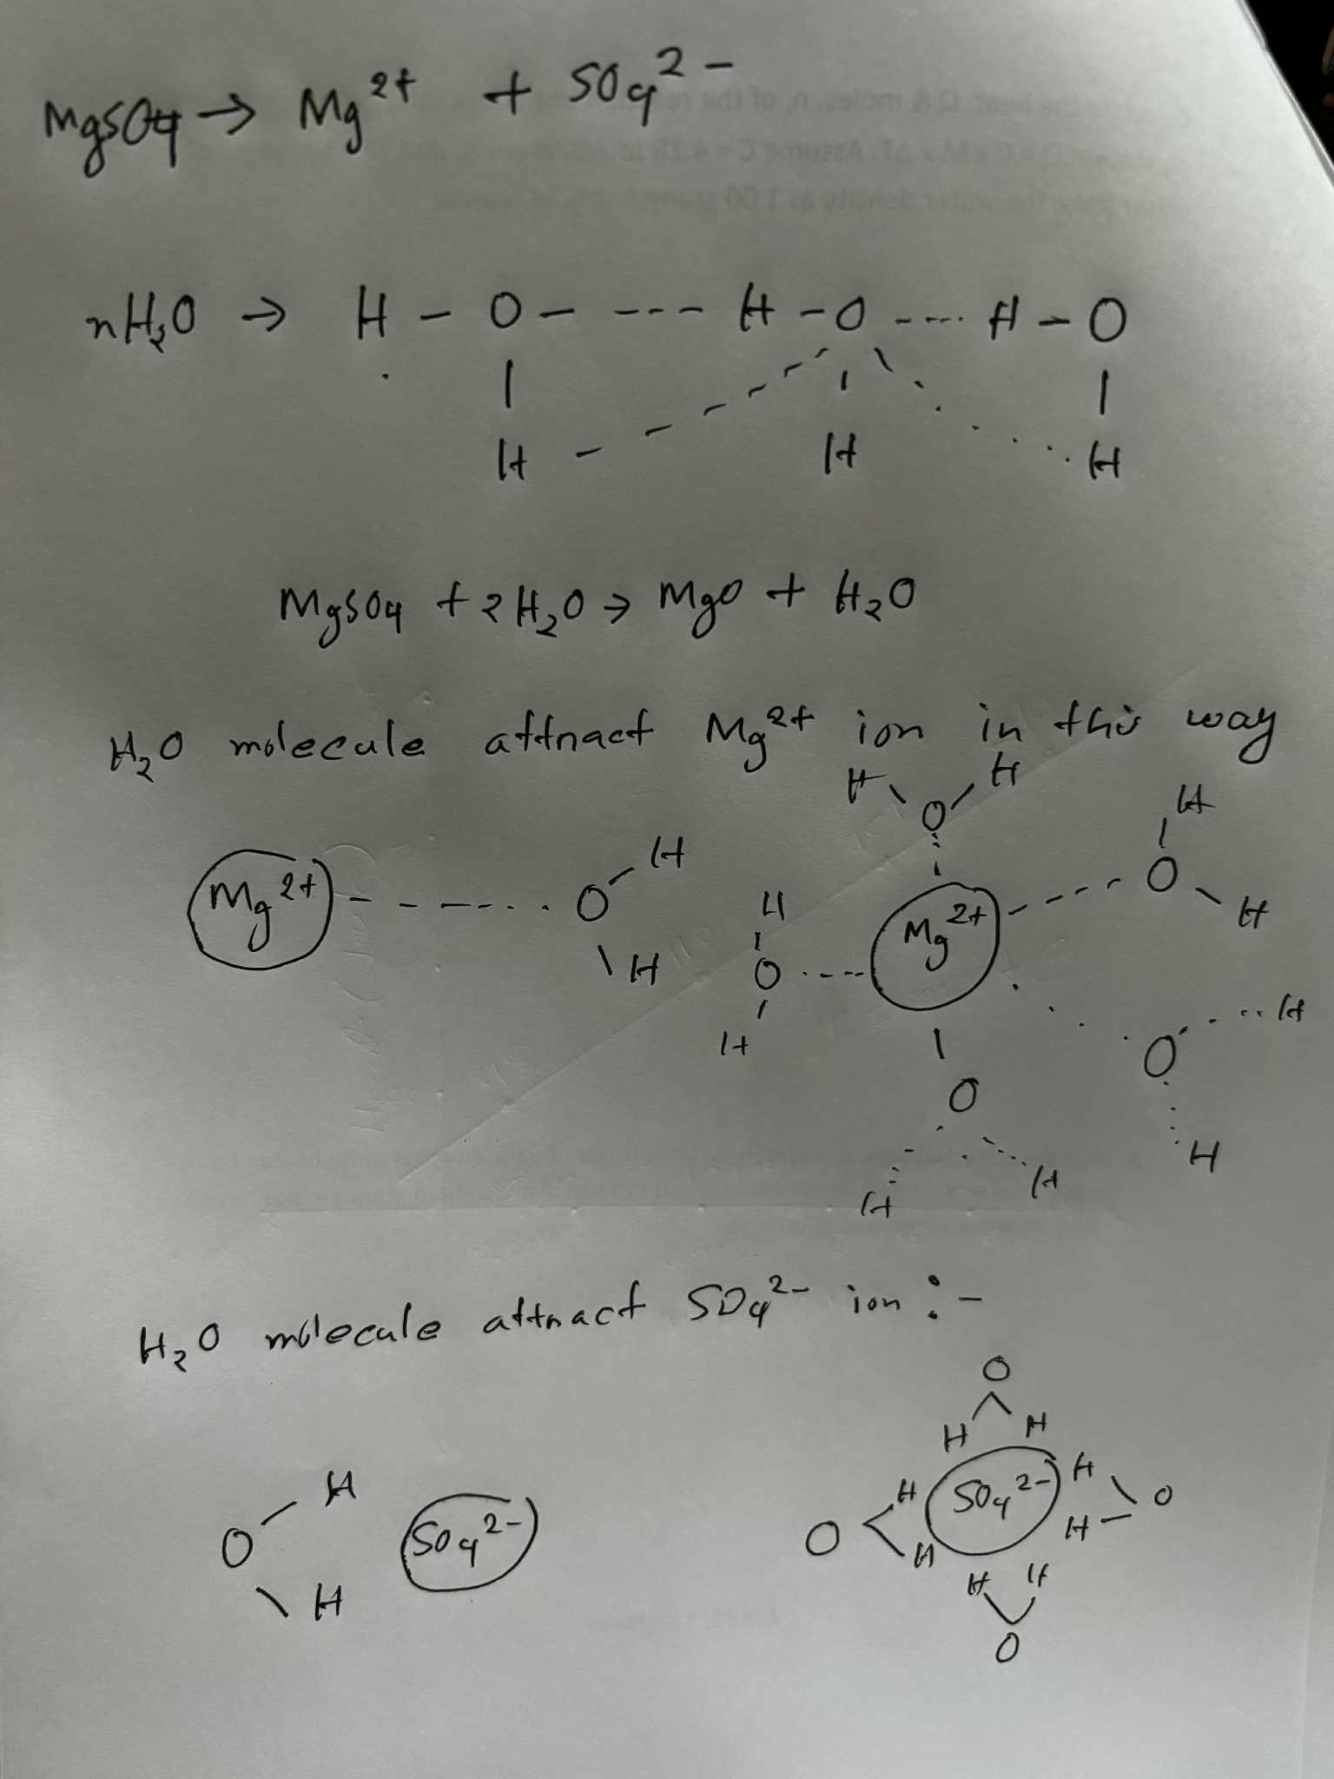
In this case, hydration enthalpy is greater than the bonding energy, So, the solid dissolves & the temperature of the solution increases indicating the reaction is exothermic.

